Nikolajs research results

LSTM

Original LSTM predictions on 2024
The exact same model from phase 1 with parameters:
• Hidden size: [64]
• Layers: [3]
• Learning rate: [0.001]
• Batch size: [64]
• Sequence length: [24]
• Dropout: [0.2]
Pedictions for 2024:
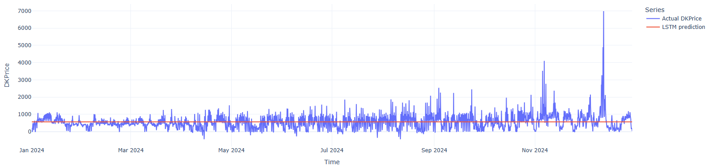
A constant predicted value of 563.39 DKK/MWh

Original LSTM trained on true values
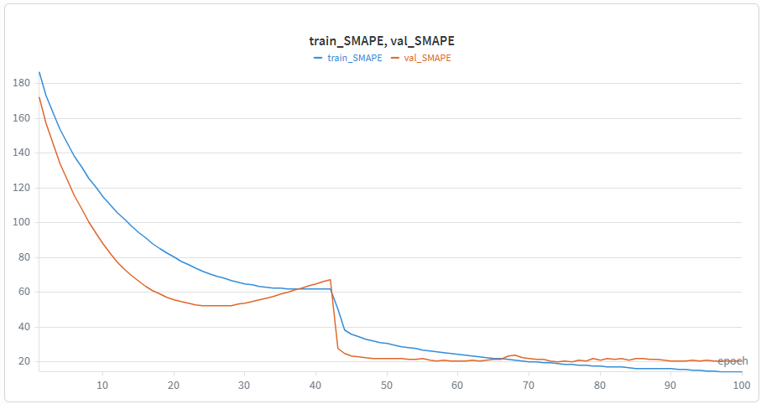
Best epoch = 74, train_SMAPE = 19.30, val_SMAPE = 20.24
Predictions for January 2025:
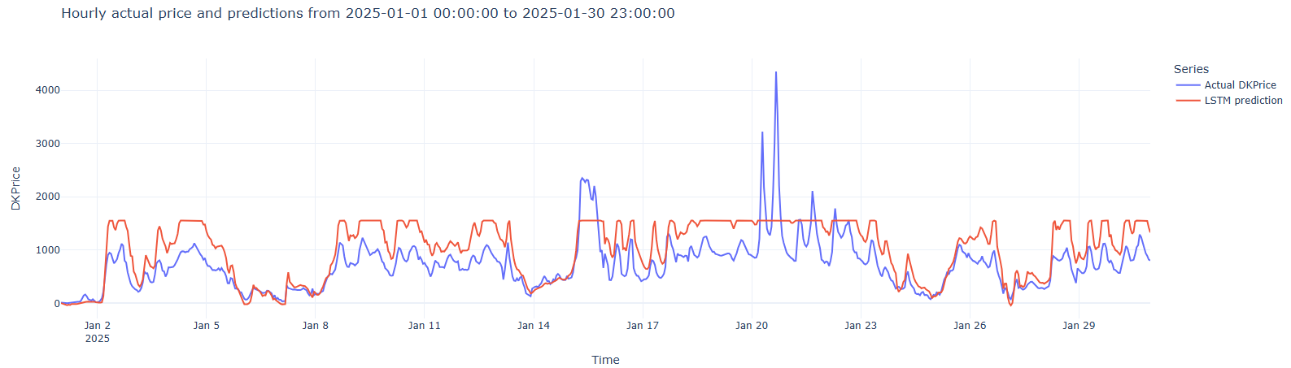
Maks value = 1554.36
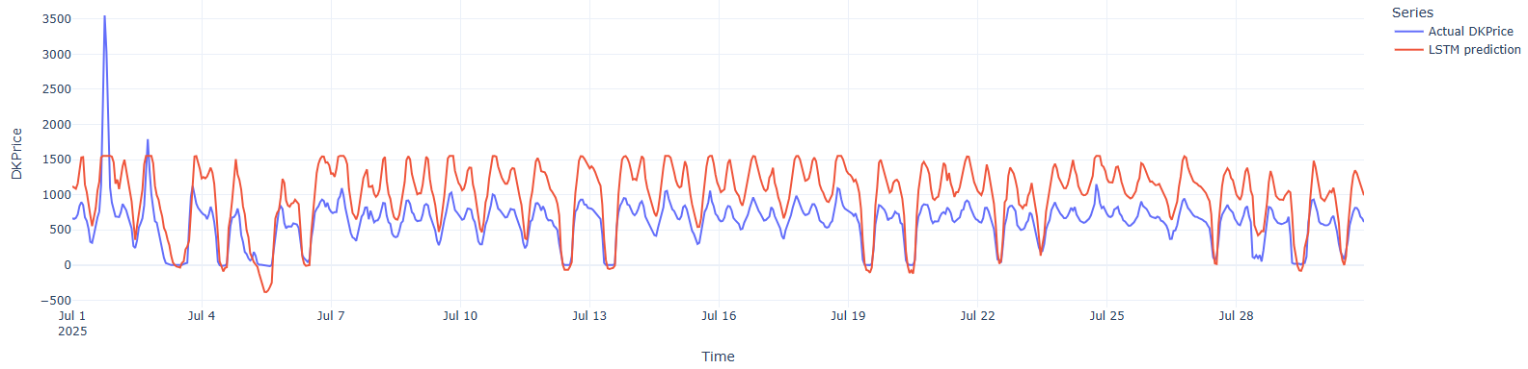
Maks value = 1554.36

Original LSTM true values, MSE val
Training conditions:
- The original LSTM parameter values
- True explanatory features values
- Original train / val split
- MSE as validation and selection metric
- Best epoch: 74
- Early stopping, patience = 30, max epochs = 150
- Best train_MSE = 325904.24
- Best val_MSE = 5099
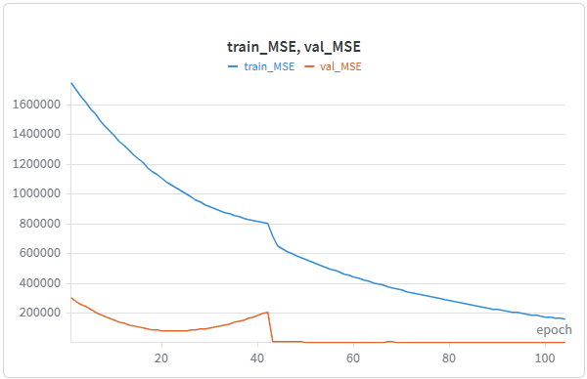
Predictions on Jan 2025:
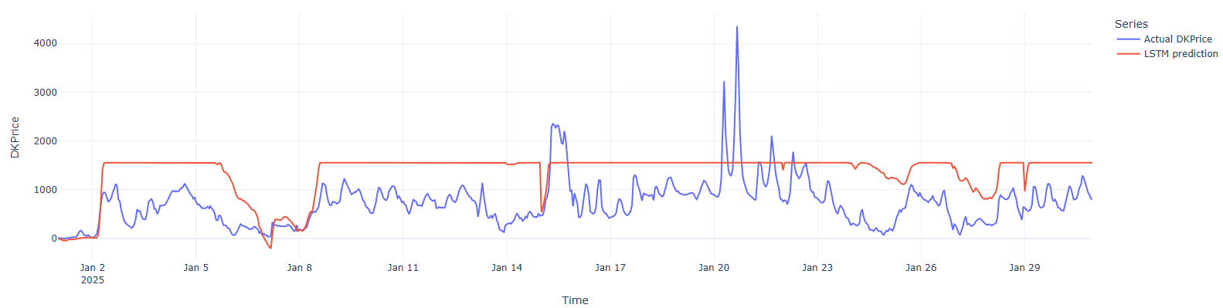
Maks value = 1554.36
Predictions for July 2025:
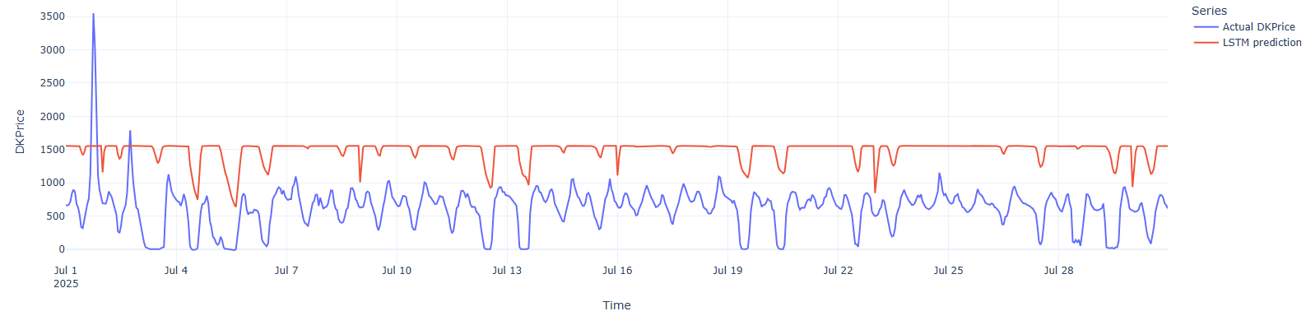
Maks value = 1554.36

Maks value = 3018.74

